Follow up Reminders:
User Story: As a realtor, I want a reminder (like a notification banner, popup, or bell icon) for upcoming follow-ups that doesn’t interrupt my work, so that, I can stay on track and follow up on time.
I want to customize reminder settings, such as choosing the reminder time (e.g., 15 minutes, 1 hour, 1 day before) and the type of notification (popup, email, SMS, WhatsApp), so that, I can receive timely and personalized follow-up alerts.
- User should be able to set preferences on how they want their notifications to be sent and should be able to set the time to remind about upcoming and overdue meetings. User can navigate to this screen from user settings.
- User can set multiple notification methods so option to choose the kind of notification must be of checkbox.
- A button to save the preferences and a button to reset the preferences to default settings.
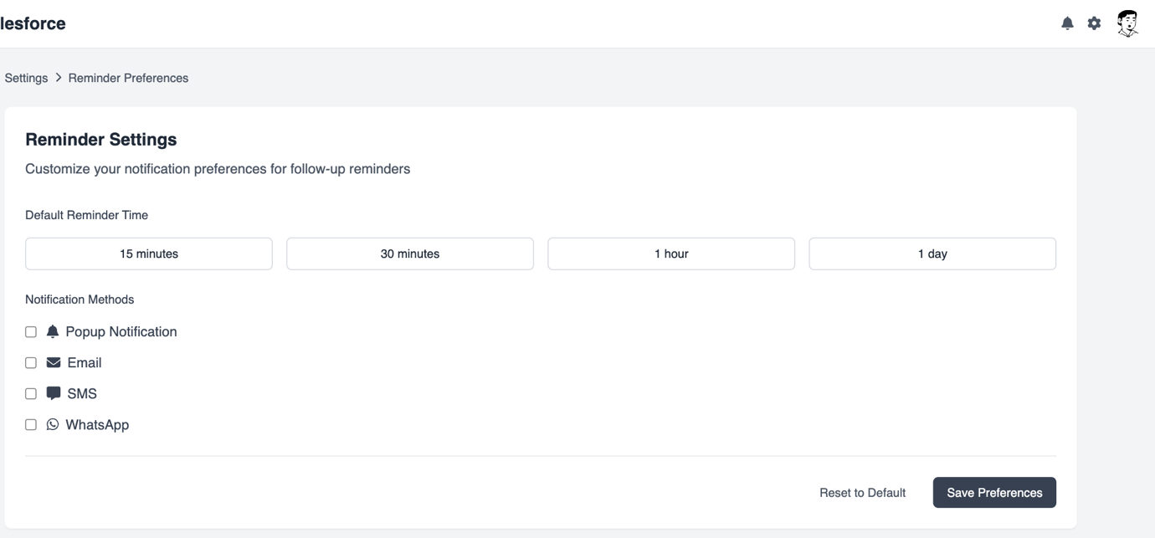
- User should be able to see the reminder notifications when clicked on the bell icon on the top right corner of the salesforce screen. A notification should have a quick summary of the upcoming or overdue meeting as shown in below screenshot.
- All the notifications must have an option to snooze or dismiss.
- Notification can be of multiple kinds like the one shown when bell icon is clicked and other can be a popup. (As given in screenshots)
- Overdue notifications must be distinct with red in colour.
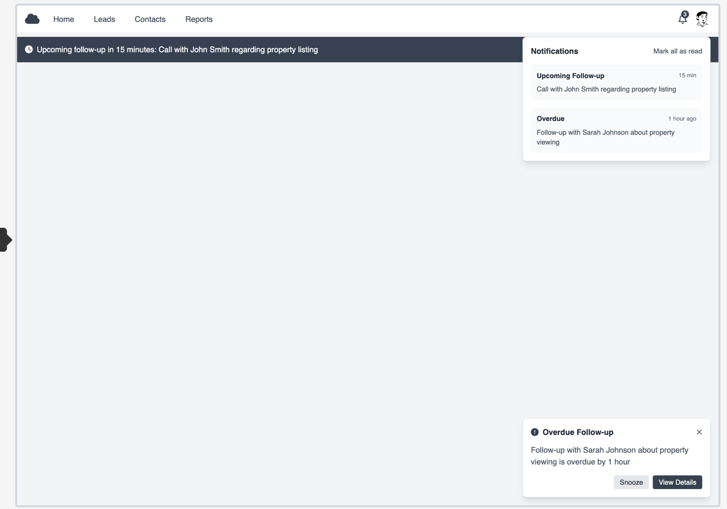
Popup notifications must be like the ones in the below picture. Buttons like snooze and complete must be in the popup alert.
